- \Operation\Basic settings\Reference offset values
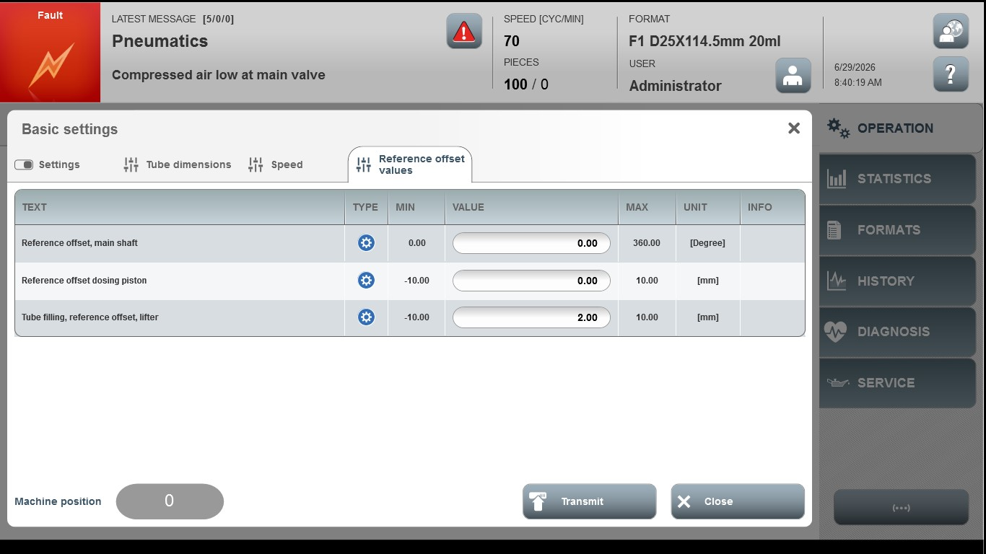
Acceptance criterion | Limits | Pass / Fail: Dev-No. | Date | Initials
Screen matches screenshot | N / A
Reference offset, main shaft | 0.00 …360.00
Reference offset dosing piston | -10.00 … 10.00
Tube filling, reference offset, lifter | -10.00…10.00

